Smart Plant Health Monitoring and Management System: Leveraging AI for Precision Agriculture
Kambham Salivahana Reddy ¹
Faculty, Department of CSE
KSRM College of Engineering
Kadapa, Andhra Pradesh
kshalivahanreddy@gmail.com

Kavali Anjineyulu ⁴
Student, Department of CSE
KSRM College of Engineering
Kadapa, Andhra Pradesh
kavalianjikavalianji@gmail.com
Peddamudium Praveen Kumar ²
Student, Department of CSE
KSRM College of Engineering
Kadapa, Andhra Pradesh
primepraveen111@gmail.com

Mallangi Gayathri ⁵
Student, Department of CSE
KSRM College of Engineering
Kadapa, Andhra Pradesh
gayathrimallangi@gmail.com

Ponna Sirisha ³
Student, Department of CSE
KSRM College of Engineering
Kadapa, Andhra Pradesh
ponnasirisha144@gmail.com

Abstract— Food security depends heavily on agriculture, yet issues including poor crop selection, wasteful fertilizer use, plant diseases, and inadequate growth control have a big influence on productivity and production. Accurately diagnosing plant illnesses, choosing the finest fertilizers depending on soil conditions, choosing the proper crops for particular seasons and geographical areas, and gaining access to trustworthy growth management techniques are all challenges that farmers frequently face. Reduced agricultural productivity, higher expenses, and unsustainable farming methods are the results of these inefficiencies. We suggest a Smart Plant Monitoring and Control System that uses data-driven insights and machine learning to improve decision-making in order to address these issues. The system has four main components: (1) Seasonal-Based Crop Recommendation: This ensures optimal yield by suggesting appropriate crops based on the Andhra Pradesh district selected and the agricultural season (Kharif, Rabi, etc.); (2) Fertilizer Recommendation: Using Exploratory Data Analysis (EDA) and a Decision Tree Classifier, this model achieves 98.9% accuracy in recommending fertilizers based on soil parameters and weather patterns, promoting effective resource use; (3) Crop Disease Detection: Using data augmentation and a Convolutional Neural Network (CNN) model with 99.14% reliability to detect illness and suggest preventive actions; and (4) Plant Growth Tips: This integrates the YouTube API to retrieve instructional videos and offers farmers professional advice on plant care.
Keywords— Agriculture, Crop, Data, Detection, Fertilizer, Machine and Recommendation System.

Introduction
For ages, agriculture has supported economies and guaranteed food security, serving as the foundation of human civilization. Over time, traditional farming methods have changed from being labor intensive and manual to being mechanized and propelled by technology [1]. During the Green Revolution, hybrid crops, irrigation systems, and scientific farming methods greatly raised agricultural productivity. However, farmers still struggle to make well-informed decisions on crop selection, fertilizer use, disease prevention, and crop growth management in spite of technological developments [2]. An intelligent, data-driven agricultural system is more important than ever as climate change and erratic weather patterns continue to affect farming results. The way farmers handle their crops has been completely transformed in recent years by the application of machine learning (ML) and artificial intelligence (AI) in agriculture. Predictive modelling, early disease identification, and efficient resource allocation are made possible by AI-powered systems. Using image processing techniques, a number of artificial intelligence models have been created to evaluate soil characteristics, suggest fertilizers, and track plant health [3]. These developments have increased productivity and decreased crop losses, but the majority of current solutions don't take a holistic approach that unifies several farming facets into a single, intuitive system. Due to expensive prices, a lack of technical expertise and spotty internet connectivity, small-scale farmers, particularly those in developing nations, find it difficult to obtain such technology.
The current agricultural management systems lack an integrated approach and instead concentrate on discrete elements like disease detection, fertilizer recommendations, and crop recommendations. While some AI-based platforms require complicated installations that are unfeasible for small farms, others offer generalized advice that do not take region-specific characteristics into account [4]. Furthermore, the majority of disease detection models only use picture classification, ignoring other environmental factors, which results in predictions that are less reliable. Furthermore, a lot of farmers continue to use trial-and-error techniques and conventional expertise, which leads to ineffective farming methods and large losses. It is challenging for farmers to optimize their yield potential in the absence of a comprehensive, intelligent agricultural system that integrates crop selection, fertilizer advice, disease diagnosis, and growth management. This initiative is driven by the pressing need to use data analytics and artificial intelligence to improve farming techniques [5]. Unpredictable weather, bad soil, and limited access to scientific knowledge cause financial difficulties for many farmers. We aim to close the gap between traditional farming and technology by creating an AI-powered agriculture assistant that will enable even small-scale farmers to use smart decision-making tools [6]. Our system encourages precision farming, which helps farmers produce nutritious crops with less losses, improving economic stability, sustainability and food security.

LITERATURE SURVEY
In order to increase production and sustainability, a number of previous research have investigated the integration of machine learning (ML) and artificial intelligence (AI) in agriculture. Using machine learning algorithms like Random Forest, Support Vector Machines (SVM), and Decision Trees, researchers have created crop recommendation systems that select the best crops for a particular area by analyzing soil characteristics, weather patterns, and historical yield data. Furthermore, deep learning and logistic regression approaches have been used to develop fertilizer recommendation models that take into account the amounts of potassium, phosphorus, nitrogen, and pH in the soil [7]. Farmers have benefited from these models by using fertilizer more efficiently, saving money, and lessening their influence on the environment. However, the actual uses of these systems were limited due to their lack of real-time adaptability and failure to take localized environmental fluctuations into account.
Ojo et al. examines the use of Deep Learning (DL) in Controlled Environment Agriculture (CEA) infrastructure, with particular attention to yield estimation (31%), growth monitoring (21%), and greenhouses (82%). Most research employ accuracy (21%), CNN (79%) and Adaptive Moment Estimation (53%) [8]. The study also shows that the most widely employed DL evaluation metric in CEA microclimates is RMSE. Current issues and potential avenues for further research in this area are also covered in the article. Wang et al. examined that global agricultural productivity is under strain from the COVID-19 epidemic, population expansion, and climate change. Precision agriculture (PA) is using artificial intelligence, sensor technology, and autonomous systems to address this [9]. High-resolution farmland photos are being produced using unmanned mobile platforms and high-performance photography sensors. It can be difficult to effectively use these photos for fine crop adjustment, though. In agriculture, deep learning (DL) has demonstrated promise, especially for image-based farmland observations. CNN-SL, TL and FSL are the main uses for deep learning in multiscale agriculture remote and proximal detection that are the subject of this review.
Darwin et al. in a variety of settings, precision agriculture is essential to increasing agricultural yields [10]. After a pandemic, automation in the agriculture sector can lower resource consumption and enhance food quality. Seeding, tracking, weed control, management of pests, and harvesting are all done by agricultural robots. When predicting crop productivity, remote sensing technologies provide precision and dependability. Smart farming is more accurate when deep learning techniques are used. The average accuracy of traditional deep learning methods is 92.51%. This study investigates several automated methods for detecting crop yield, such as classifier and virtual analytic techniques. Several computer vision methods and deep learning models, including Convolutional Neural Networks (CNNs), Res-Net, and VGG-Net, have been used in the field of crop disease identification to categorize plant diseases from leaf photographs. To increase classification accuracy, some have also used transfer learning and data augmentation [11]. Despite their great accuracy, these methods are less accessible to small-scale farmers since they frequently need for substantial processing resources and vast datasets. Furthermore, not much has been done to combine real-time plant growth suggestions with disease detection. Recent developments have also investigated chatbots and Natural Language Processing (NLP)-based agricultural aid systems, however they mostly concentrate on responding to farmers' questions rather than offering all-inclusive AI-driven solutions.

DATA COLLECTION & PREPROCESSING
Any deep learning-based agricultural system must start with data collection because the accuracy and dependability of the model are directly impacted by the quality and usefulness of the data. Data for this study came from a variety of sources, including open-source datasets about crops, fertilizers, plant diseases and conditions in the environment; government agricultural databases; weather reports; and soil testing organizations. District-by-district data from Andhra Pradesh covering climate variables like temperature, precipitation, humidity, and soil type is part of the dataset supporting seasonal crop recommendations. Historical information on weather, crop-specific fertilizer usage patterns, and soil characteristics (pH, nitrogen, phosphorus, and potassium levels) was gathered in order to make fertilizer recommendations. Images of both healthy and damaged plant leaves from agricultural research facilities, Plant-Village and Kaggle make up the disease detection dataset. Images of both healthy and damaged plant leaves from agricultural research facilities, Plant-Village and Kaggle make up the disease detection dataset. Plant species and disease kinds were used to better categorize these photos. Additionally, the YouTube API, which fetches instructional videos pertinent to the chosen crops and diseases, was used to integrate real-time plant development information.
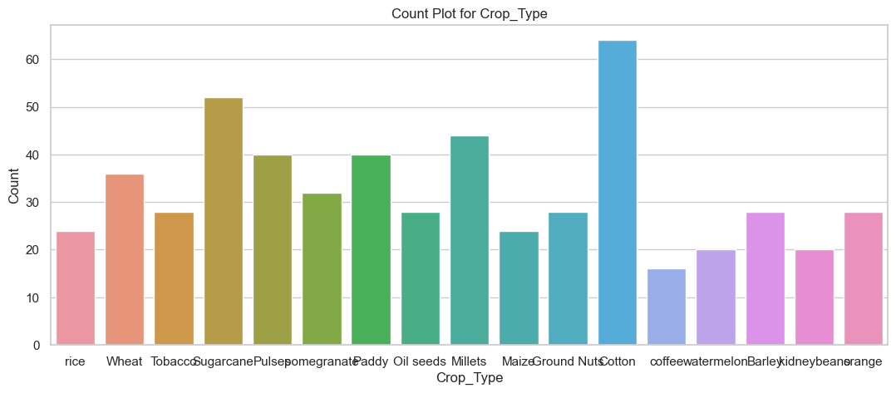
Fig.1 Count Plot of Crop Types
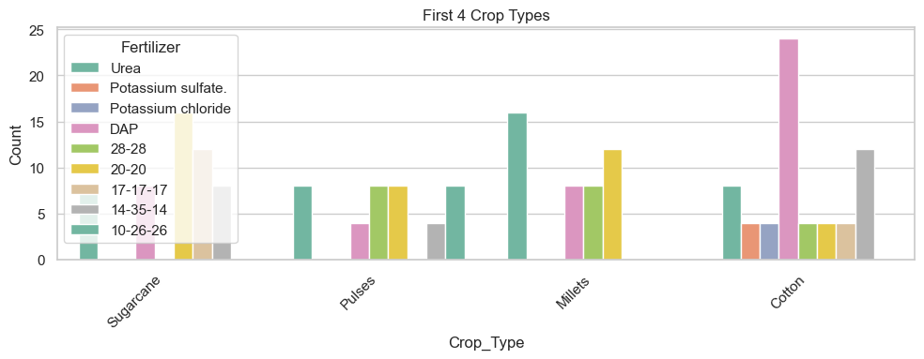
Fig.2 Fertilizer vs Crop Type
The preparation phase, which follows data gathering, makes that the data is sanitized, organized and appropriate for machine learning systems [12]. Because agricultural datasets frequently contain partial records as a result of irregular data reporting, resolving missing values is the first step in preprocessing. For numerical characteristics like temperature, soil pH, and humidity, imputation techniques like mean, median, and mode replacement are used to make sure that missing values don't affect the accuracy of the model. Mode imputation or predictive modelling approaches are used to fill in the missing values for categorical variables, such as crop type and soil classification. Furthermore, extreme values that can skew forecasts are found and eliminated using outlier identification techniques like Z-score analysis and IQR (Interquartile Range) filtering, particularly in datasets pertaining to weather and fertilizer recommendations. In order to guarantee consistency across variables, feature scaling and normalization are essential for fertilizer recommendation models. Min-Max Scaling and Standardization (Z-score normalization) [13] is used to bring all numerical characteristics to a common range because different parameters, such as soil pH, amount of nitrogen, and temperature, function on different scales. By doing this, specific features are kept from controlling the model training procedure. Similarly, to transform categorical variables like soil type, crop variety, and season into machine-readable representations, categorical encoding techniques like One-Hot Encoding and Label Encoding are used. For models like Decision-Tree, which function better with numerical information representations, this modification is crucial.
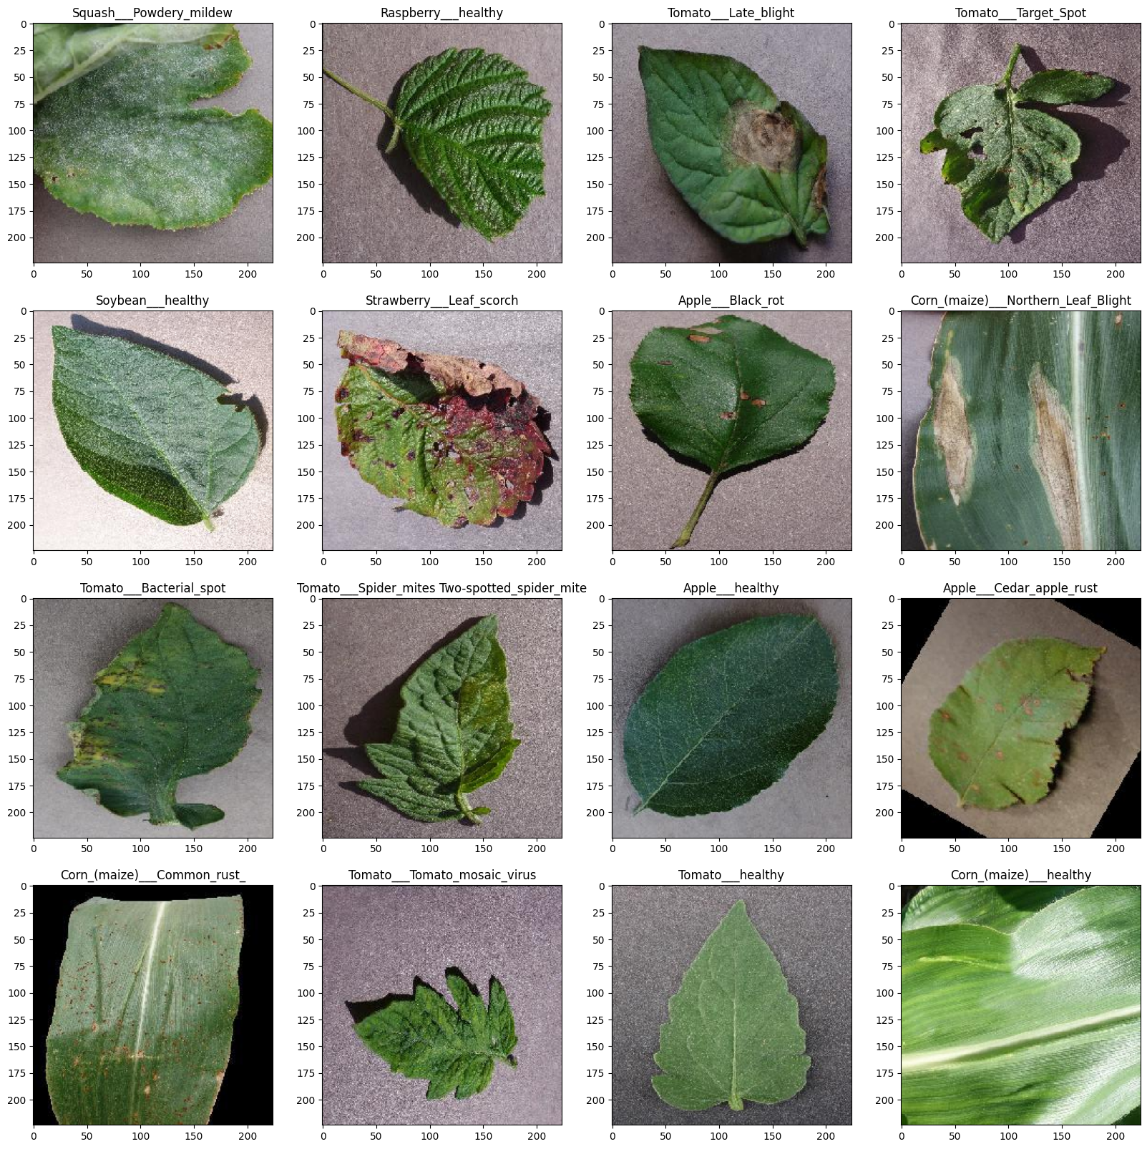
Fig.3 Data Collection of Images
Image preprocessing methods are used to improve data quality and guarantee reliable training for CNN models used in illness detection. By applying various rotations, flips, brightness tweaks, and contrast improvements to preexisting photos, data augmentation is done to artificially increase the dataset's size. This lessens overfitting and increases generalization, which enhances the model's capacity to identify illnesses in a variety of settings. Additionally, as irregular image sizes can result in computational inefficiencies, image scaling and normalization are used to provide consistent dimension information for the CNN model [14]. Additionally, Histogram Equalization is employed to enhance visual contrast, which helps the deep learning network identify illness patterns. The YouTube API is used to get text-based data for plant growth suggestions, which is then preprocessed using Natural Language Processing (NLP). Tokenization, stop-word elimination, stemming and lemmatization are used to extract pertinent keywords from comments and video descriptions. Only top-notch, instructive movies are suggested to farmers thanks to the usage of Word Embeddings and TF-IDF (Term Frequency-Inverse Document Frequency) to assess the relevancy of video content. In order to improve the recommendation process, semantic similarity approaches like cosine similarity are also used to eliminate irrelevant movies and duplicate items.

PROPOSED METHODOLOGY
Several AI-powered components are included into the planned Smart Plant Monitoring and Management System in order to improve agricultural decision-making. The four primary components of the technique are Plant Growth Guidance, Crop Disease Detection, Fertilizer Recommendation, and Seasonal Crop Recommendation. Using Decision Tree Classifier for accurate suggestions, the Seasonal Crop System of recommendations uses soil factors and historical climatic data to identify the best crops for a particular Andhra Pradesh district. Based on crop type, weather, and soil nutrient levels, the Fertilizer Recommendation module uses a Decision Tree Classifier and Exploratory Data Analysis (EDA) to recommend the best fertilizers. A Convolutional Neural Network (CNN) developed with data augmentation approaches is employed for Crop Disease Detection. Lastly, to guarantee that farmers receive current and aesthetically instructive assistance, the Plant Growth assistance module uses the YouTube API to retrieve pertinent teaching videos. In order to provide smooth communication between users and the model, the complete system is implemented using streamlit for a user interface and a SQL database for effective data management.

Seasonal Trends Analysis

In agriculture, studying seasonal trends is essential for comprehending how weather, soil conditions, and crop yields vary with the seasons. The Kharif, Rabi, and Zaid seasons are the main divisions of India's agricultural cycles, and they are all impacted by weather variables like humidity, temperature, and rainfall. Farmers can maximize yields and improve planting schedules by examining previous crop production data. Based on district-level data from Andhra Pradesh in India [15], this analysis takes temperature fluctuations, rainfall distribution, and soil fertility into account when recommending seasonal crops. By suggesting the most robust crops for each season, this method aids in reducing the risks related to soil degradation, unpredictable monsoons, and climate change. Seasonal trend analysis affects irrigation planning, fertilizer use, and insect management as well as to crop recommendations. For instance, Rabi crops are helped by fertilizers based on phosphorus because of their reduced moisture content, while Kharif crops, which are fed by the monsoon, need fertilizers high in nitrogen. Moreover, early diagnosis and preventive interventions are made possible by an awareness of seasonal disease patterns, which lowers crop losses from pests and fungal illnesses that prefer particular climates.

Fertilizer Recommendations
In order to maximize soil fertility, increase crop production, and guarantee sustainable farming methods, fertilizer suggestions are essential. The suggested method makes fertilizer recommendations based on crop type, soil composition, and weather patterns by utilizing a Decision Tree Classifier and Exploratory Data Analysis (EDA) [16]. In addition to climatic variables like temperature, humidity, and rainfall patterns, the dataset contains important soil metrics like nitrogen (N), phosphorus (P), potassium (K), pH levels, organic matter content, and moisture levels. To guarantee balanced nutrient application, trends in the loss of nutrients across several crops and seasons are examined using EDA. With a 98.9% accuracy rate, the Decision Tree Classifier forecasts the best kind of fertilizer to use, guaranteeing that crops get the correct amount of nutrients at the proper time. This data-driven strategy aids in avoiding both under fertilization, which can lower production potential, and overfertilization, which can deteriorate soil quality.

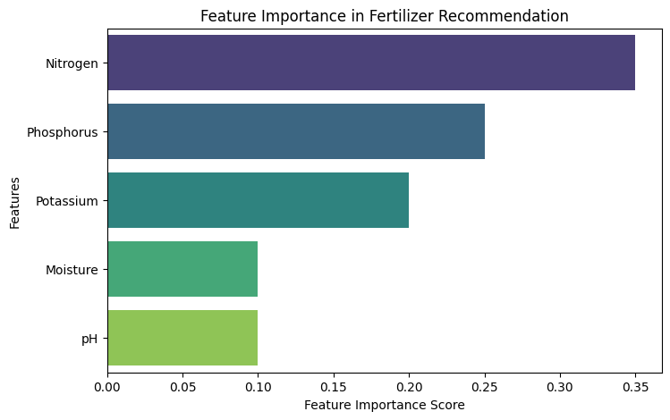

Fig.4 Feature Importance of Decision Tree

In order to provide farmers with tailored fertilizer recommendations, the system of suggestions also takes into account regional agricultural practices. In order to promote root development, leguminous crops might need fertilizers based on phosphorus, whereas crops grown on rainfall like rice or maize might need fertilizers high in nitrogen. In order to reduce nitrogen loss from drought or heavy rainfall, the system also uses real-time climate information to constantly adjust fertilizer recommendations. This method reduces farmer expenses, encourages ecologically appropriate farming methods, and lessens reliance on guesswork by fusing machine learning with actual agricultural statistics. Additionally, the technology enables farmers to monitor past consumption trends by recording fertilizer recommendations in a SQL database, enhancing precision agriculture and long-term soil health monitoring.

Crop Disease Detection

A key element of precision agriculture is crops disease detection, which aids farmers in spotting plant infections early on to stop extensive harm. The suggested method classifies plant illnesses with 99.14% accuracy by combining Convolutional Neural Networks (CNNs) [17] with augmenting data approaches. A large dataset of photos of both healthy and sick plants from a range of crops is used to train the algorithm. Rotation, flipping, scaling, and lighting modifications are examples of data augmentation techniques that increase the variety of training data and strengthen the model's resilience in practical settings. The CNN model analyses the image, extracts important characteristics, and categorizes the disease when a farmer uploads a picture of a potentially afflicted plant. The system then offers practical suggestions for halting the disease's development, such as the use of suitable pesticides, organic remedies, and preventative measures.

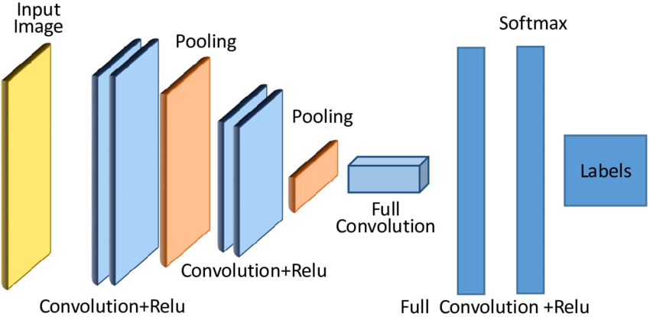

Fig.5 CNN Architecture

Farmers can now identify plant health problems in real time thanks to an automatic disease detection technology, which drastically cuts down on manual labor and the need for agricultural specialists. Because of its integration with a streamlit-based user interface, even non-technical users may easily utilize and comprehend the model. Long-term surveillance and early intervention techniques are also made possible by past disease patterns kept in a SQL database [18]. Using variables like temperature, humidity, and soil moisture, the method also links disease outbreaks to environmental circumstances, assisting in the prediction of possible hazards. Farmers may minimize crop losses, cut down on pesticide abuse, and increase overall agricultural production by utilizing AI-driven disease diagnosis, which will result in sustainable and economical farming methods.

Plant Growth Guidance

A combination of good soil management, nutrient delivery, disease avoidance, and climate adaptation is needed to ensure the best possible plant development. A Plant Growth Advice module in the suggested system offers farmers data-driven suggestions and instructional materials to assist them optimize crop productivity. The YouTube API [19], which powers this module, retrieves pertinent agricultural videos according to the crop, season, and plant health problems that have been discovered. Farmers get access to educational DVDs covering subjects like organic farming, pest control tactics, irrigation methods, pruning procedures, and optimum sowing practices. This approach improves knowledge transmission by providing visual, practical demonstrations, allowing farmers to implement the best farming practices specific to their area and crop type.

The technology offers tailored plant development strategies by combining predictive insights from disease detection, fertilizer recommendations, and soil health in addition to video-based learning. To guarantee that nutrients are delivered at the appropriate developmental stage, the system can, for example, offer growth-stage-specific advice in addition to fertilizer recommendations to farmers [20]. The website also monitors seasonal climatic trends and provides advice on water conservation, drought-resistant gardening, and safeguards against severe weather. Farmers are empowered with scientific, field-tested information through the combination of AI-based suggestions with digital instructional content, which helps them increase agricultural produce quality, decrease losses, and increase production.

RESULTS
The effectiveness of several predictive models, immediate evaluation, and interactive output visualization with streamlit were used to assess the Smart Plant Health Monitoring and Management System. Accuracy, precision, recall, and F1-score criteria were used to evaluate the system's efficacy, and the findings show how well it handles a variety of agricultural jobs. The Decision Tree Classifier-powered crop recommendation system successfully recommended crops based on district-specific seasonal patterns, soil fertility, and meteorological parameters, achieving 98.9% accuracy. The Decision Tree Classifier-based fertilizer recommendation algorithm accurately predicted the nutrients needed to ensure the best possible soil health and crop output. The CNN model used for this study demonstrated an outstanding 99.14% accuracy in crop disease detection. In order to enhance generalization across various lighting situations, angles, and plant stages, the model was trained utilizing data augmentation techniques. A confusion matrix and loss-accuracy graphs were used to present the disease classification findings, demonstrating the model's good performance and little overfitting. Furthermore, the robustness of the model was confirmed by real-time evaluation on unseen plant photos, which accurately identified ailments and suggested suitable treatments.

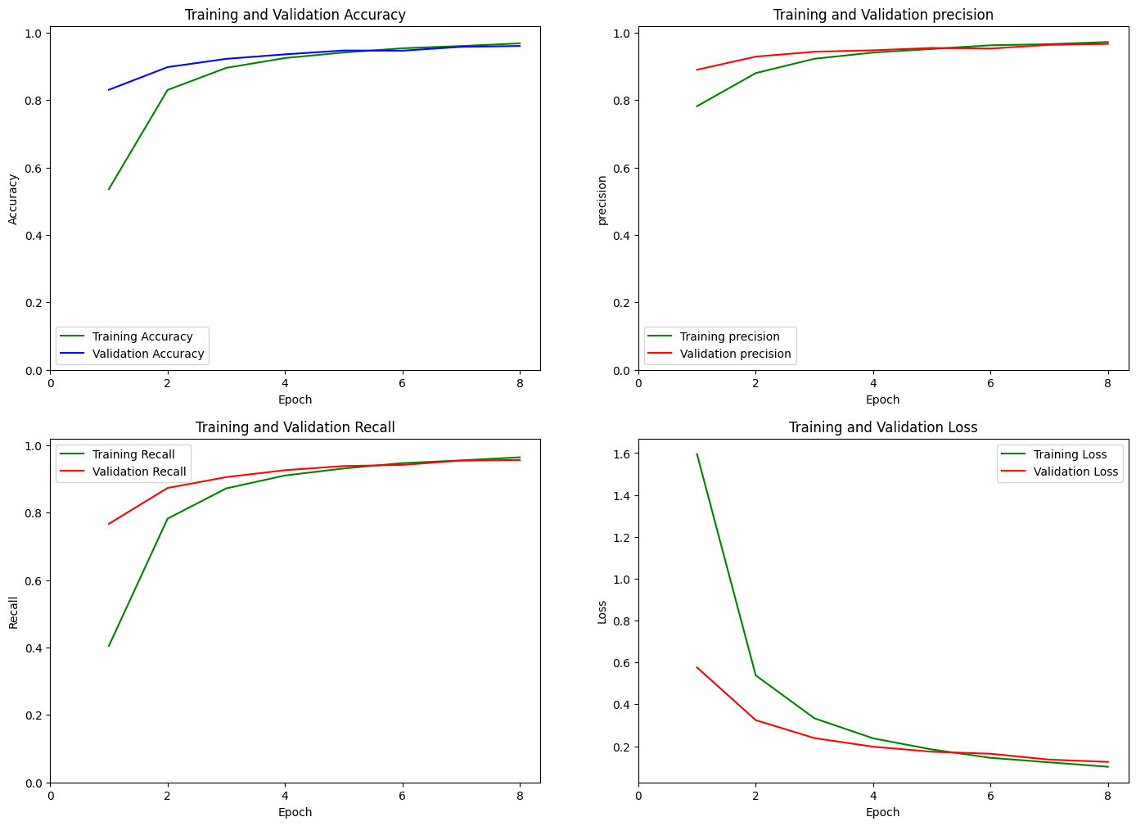

Fig.6 CNN Epochs vs Accuracy and Loss Plots

A variety of charts were used to illustrate the model's performance, such as matrices of confusion for classification models, accuracy vs. epoch graphs, loss curves, and feature significance graphs for Decision Trees. While the loss curve demonstrated efficient learning without significant overfitting, the accuracy vs. epoch plot for CNN illness detection demonstrated an ongoing boost in performance with each epoch. The fertilizer recommendation model's feature importance plot indicated that the most important soil factors for choosing the right fertilizer type were nitrogen (N), phosphorus (P), and potassium (K). Streamlit, which offers a user interface that is interactive for real-time analysis, was used to implement the system. Farmers can choose their region and season (Kharif, Rabi, or Zaid) using the crop suggestion option, and the program will offer the best crops based on past data. Using soil factors entered by the user, the fertilizer recommendation module determines the optimal fertilizer type in real time and shows it on the interface. Farmers can send photos of sick plants to the disease detection system, and the CNN model analyses them in real time to provide the expected illness name and recommended course of treatment.

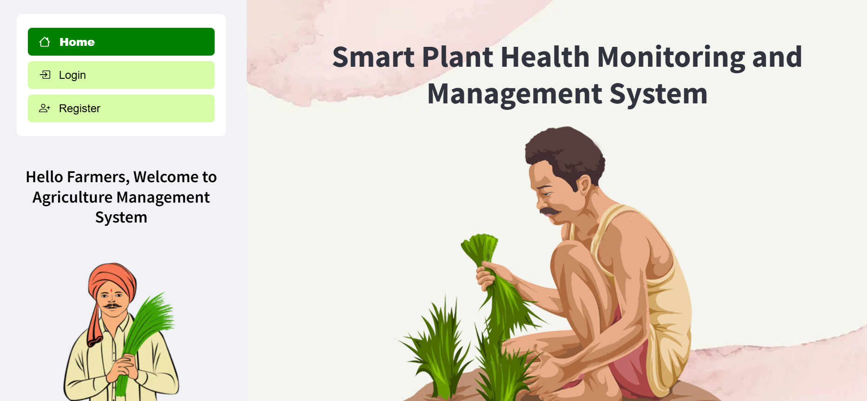

Fig.7 Streamlit User Interface

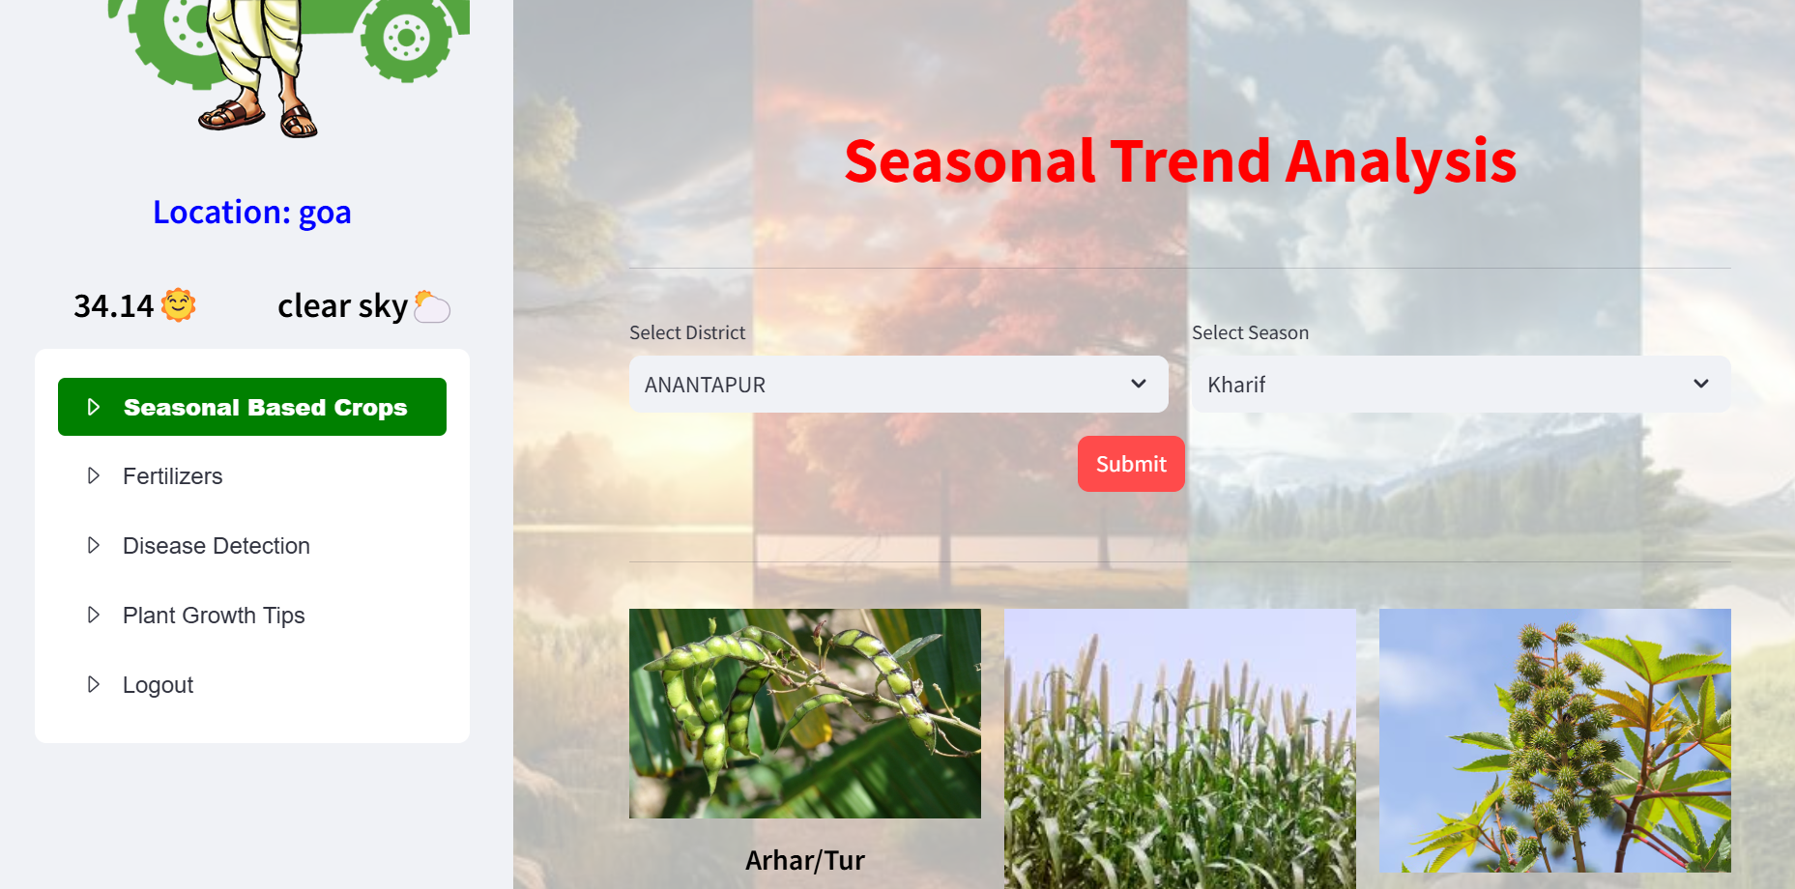

Fig.8 Seasonal Trend Analyis

Plots and dynamic graphs were added to the streamlit interface to improve the user experience. A bar chart illustrating the suggested nutrient content is used to showcase the fertilizer recommendation results. In order to help farmers visualize previous crop yields and choose the most lucrative crops, the crop recommendations display seasonal crop patterns in a line graph. To ensure transparency in forecasts, disease likelihood scores are displayed with real-time picture classification output for disease detection. The system is supported by a SQL database that holds user inputs, previous recommendations, and crop medical data in order to guarantee real-time analysis and retrieval. In order to examine seasonal trends and make well-informed decisions for future planting cycles, farmers can monitor their historical data. In order to provide predictive analysis for upcoming epidemics based on environmental factors, the database includes records diseases that are commonly detected.

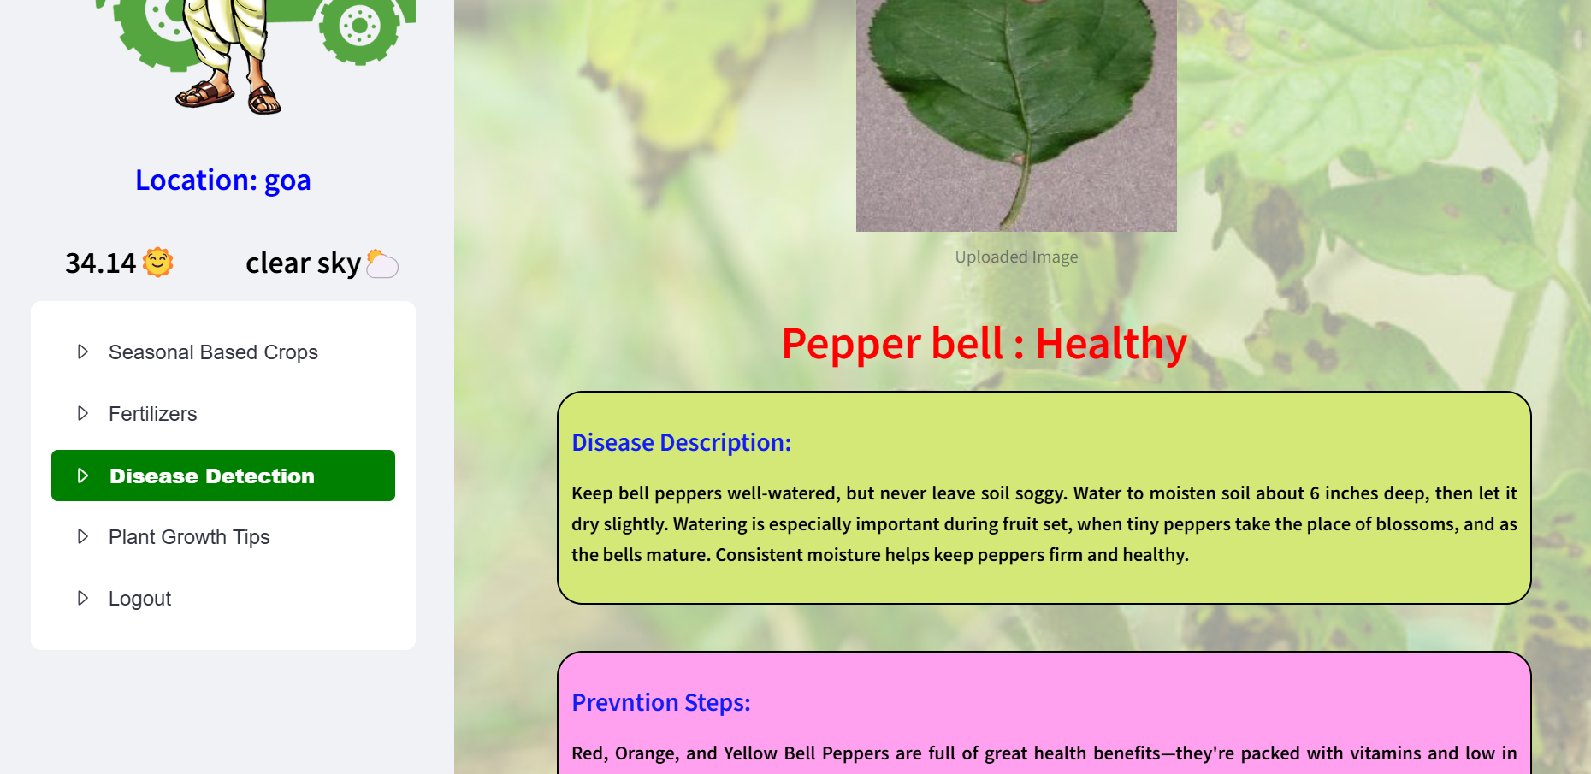

Fig.9 Leaf Disease Detection Page
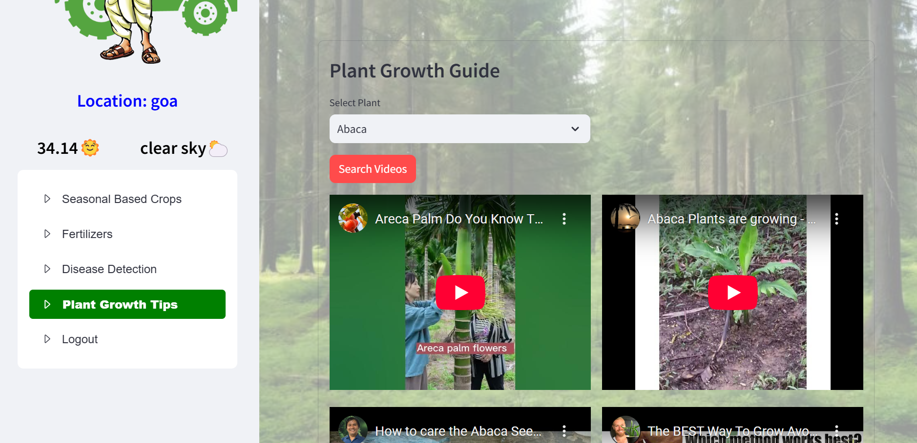

Fig.10 Plant Growth Guide

The system's effectiveness under various environmental conditions was demonstrated through testing with real-world agriculture datasets and farmer inputs. The high detection accuracy of the illness detection algorithm was confirmed through testing on recently taken photos. In order to ensure adaptation to changing conditions, the crop system offered dynamically modified suggestions based on new soil and meteorological data. The fertilizer recommendation model demonstrated its applicability in a variety of geographical locations by successfully recommending nutrients that were suited to various soil compositions. This artificial intelligence (AI) approach greatly lowers guesswork and increases efficiency when compared to conventional farming methods. For choosing crops and disease diagnosis, farmers use manual testing and local knowledge in traditional approaches, which might result in mistakes and lower yields. Higher accuracy and improved resource management result from the suggested system's automation and optimisation of these choices using machine learning models and historical data. By integrating instructional resources directly into the system, the YouTube API for plant development recommendations gives farmers even more leverage.

CONCLUSION
To help farmers with crop selection, fertilizer recommendations, disease diagnosis, and plant development guidance, the Smart Plant Health Monitoring and Management System skillfully combines machine learning, deep learning, and real-time data analysis. To achieve high prediction accuracy and ensure accurate farming and resource optimization, the system makes use of Convolutional Neural Networks, Decision Tree Classifiers, and data-driven insights. Farmers are empowered to make scientific, data-driven decisions thanks to the streamlit-based user interface and SQL database integration, which facilitate smooth user engagement and historical data tracking. The YouTube API's integration improves information accessibility even more by offering personalized farming technique video recommendations. In addition to decreasing reliance on conventional trial-and-error farming techniques, this AI-powered system boosts output, lowers losses, and enhances crop health in general. In the future, precision farming can be further improved and automated, real-time agricultural decision-making made possible by integrating satellite imaging, IoT-based smart sensors, and chatbots driven by artificial intelligence.

References
- Muradovich, Umurzakov Zufar. "SELF-PROPELLED MECHANISED PLATFORM FOR HARVESTING APPLES AND OTHER SIMILAR FRUITS." American Journal Of Applied Science And Technology 4.12 (2024): 37-41.
- Khan, Nawab, et al. "Current progress and future prospects of agriculture technology: Gateway to sustainable agriculture." Sustainability 13.9 (2021): 4883.
- He, Mingjing, et al. "A critical review on performance indicators for evaluating soil biota and soil health of biochar-amended soils." Journal of hazardous materials 414 (2021): 125378.
- Boddapati, Mohan Sai Dinesh, et al. "Creating a protected virtual learning space: a comprehensive strategy for security and user experience in online education." International Conference on Cognitive Computing and Cyber Physical Systems. Cham: Springer Nature Switzerland, 2023.
- Javaid, Mohd, et al. "Understanding the potential applications of Artificial Intelligence in Agriculture Sector." Advanced Agrochem 2.1 (2023): 15-30.
- Walsh, Conor, et al. "Translating theory into practice: A flexible decision-making tool to support the design and implementation of climate-smart agriculture projects." Agricultural Systems 219 (2024): 104060.
- Yahaya, Sharhabil Musa, et al. "Recent advances in the chemistry of nitrogen, phosphorus and potassium as fertilizers in soil: A review." Pedosphere 33.3 (2023): 385-406.
- Ojo, Mike O., and Azlan Zahid. "Deep learning in controlled environment agriculture: A review of recent advancements, challenges and prospects." Sensors 22.20 (2022): 7965.
- Wang, Dashuai, et al. "A review of deep learning in multiscale agricultural sensing." Remote Sensing 14.3 (2022): 559.
- Darwin, Bini, et al. "Recognition of bloom/yield in crop images using deep learning models for smart agriculture: A review." Agronomy 11.4 (2021): 646.
- Huyen, Chip. Designing machine learning systems. " O'Reilly Media, Inc.", 2022.
- Rahmad Ramadhan, Laska, and Yolanda Anne Mudya. "A Comparative Study of Z-Score and Min-Max Normalization for Rainfall Classification in Pekanbaru." Journal of Data Science 2024.04 (2024): 1-8.
- Cabello-Solorzano, Kelsy, et al. "The impact of data normalization on the accuracy of machine learning algorithms: a comparative analysis." International conference on soft computing models in industrial and environmental applications. Cham: Springer Nature Switzerland, 2023.
- Reshi, Aijaz Ahmad, et al. "An efficient CNN model for COVID‐19 disease detection based on x‐ray image classification." Complexity 2021.1 (2021): 6621607.
- Tamrakar, Vandana, et al. "District level correlates of COVID-19 pandemic in India during March-October 2020." PLoS One 16.9 (2021): e0257533.
- Da Poian, Victoria, et al. "Exploratory data analysis (EDA) machine learning approaches for ocean world analog mass spectrometry." Frontiers in Astronomy and Space Sciences 10 (2023): 1134141.
- Kattenborn, Teja, et al. "Review on Convolutional Neural Networks (CNN) in vegetation remote sensing." ISPRS journal of photogrammetry and remote sensing 173 (2021): 24-49.
- Şahinaslan, Ender, and Önder Şahinaslan. "Database Recovery Techniques in Microsoft SQL Server." Int. J. Innov. Eng. Appl 6 (2022).
- Khan, M. Laeeq, and Aqdas Malik. "Researching YouTube: Methods, tools, and analytics." The sage handbook of social media research methods (2022): 651-663.
- Higgins, Suzanne, et al. "Stocktake study of current fertilisation recommendations across Europe and discussion towards a more harmonised approach." European Journal of Soil Science 74.5 (2023): e13422.

